January Classroom Notes

Hello Families!

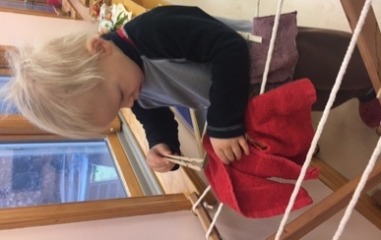
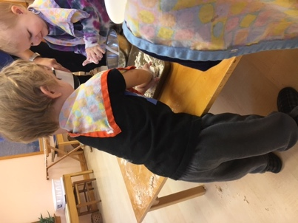
Last week was our busiest, most productive week thus far this school year! Your children are diving into the work with such efficiency and assiduity that they are feeling great big emotions of pride, accomplishment, and boosts of self- esteem. They say a picture is worth a thousand words so instead of telling you what your children are doing, I thought I would show you through many various pictures. I had the opportunity to observe our productive classroom last week and was able to capture many great shots of your children hard at work! We have also enjoyed many visits from our primary and elementary children who are reading with your children and performing songs on beautiful sounding instruments.

Thank you to Davis' family for groceries last week and to Aron's family this week. Next week it will be Eli's turn to shop for his classroom. If any of you would like a printed/ hard copy of the shopping list on the Friday before your week as opposed to an email, please let me know. I am also going to make a grocery schedule for the next ten weeks and email that to everyone this weekend.

For any of you that have an upcoming primary student and were not able to make it to the parent orientation, please email Carrie Irre for more information or any questions at cirre@mlm-school.org. Mrs. Irre also recommends that parents of rising primary students to come in and observe during the next few weeks to provide true insight on the Montessori Primary experience. Of course, I am here as well to help you with this exciting transition of your child!

Please enjoy the photos and as always you are welcome to email me with any concerns or questions!

Warmly, ok
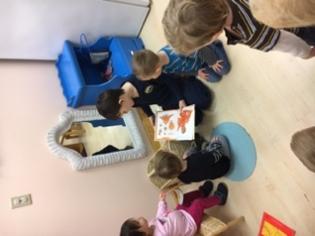
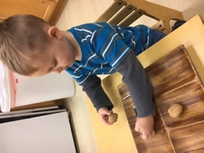
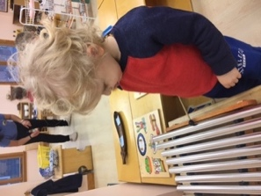
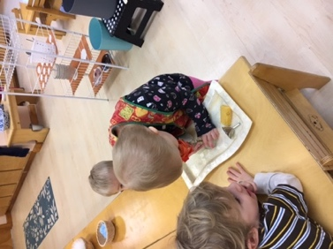
Sarah Veitenthal

Snapshots from our classroom

